Windows diagrams

The windows diagrams flow from left to write, showing the progression of selecting an activity or function and using it. The design flows well, allowing the user to have control over the system with little training involved.

1. 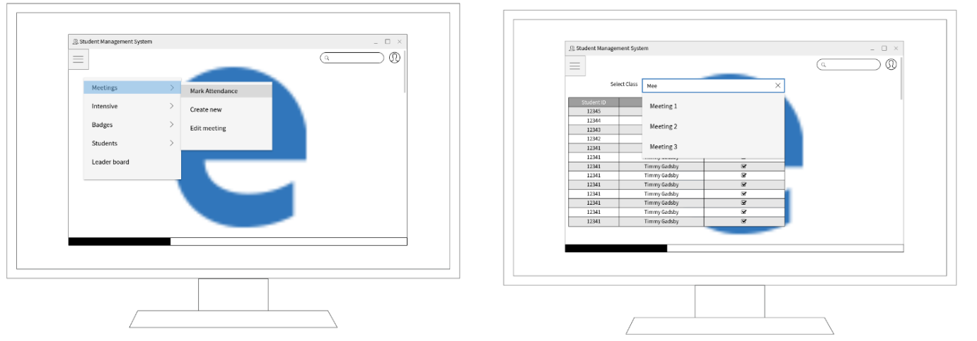Marking attendance for a meeting: you have a dropdown search box that allows you to select the appropriate class and then mark attendance.
2. 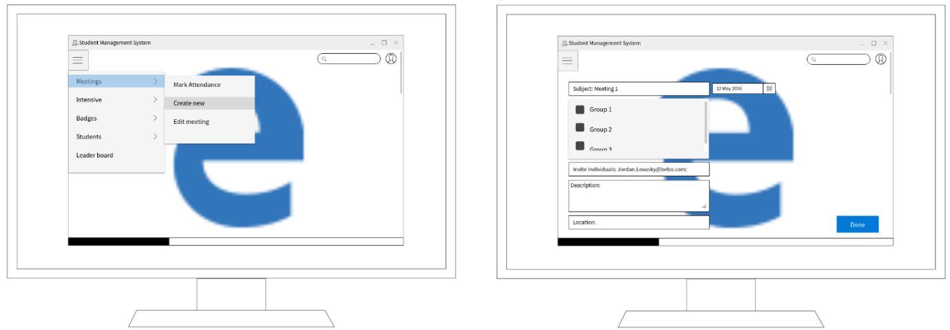 Creating a new meeting:
3. 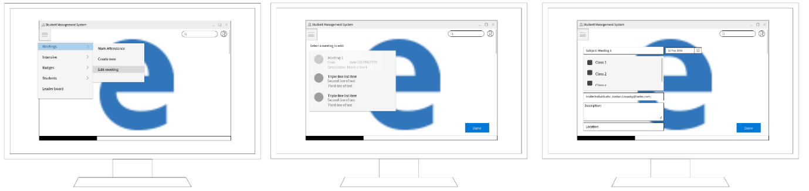Editing a meeting: here you select the meeting you wish to edit before being directed to a page like that of when you’re making the meeting.
4. Intensives are extremely similar to that of meetings, where instead of meeting, you have intensive. Thus it was redundant to create window diagrams for them.
5. Viewing badges: here you select a badge to view, and then the information regarding the badge – name, type, groups, parts, topics and requirements – are shown.
6. 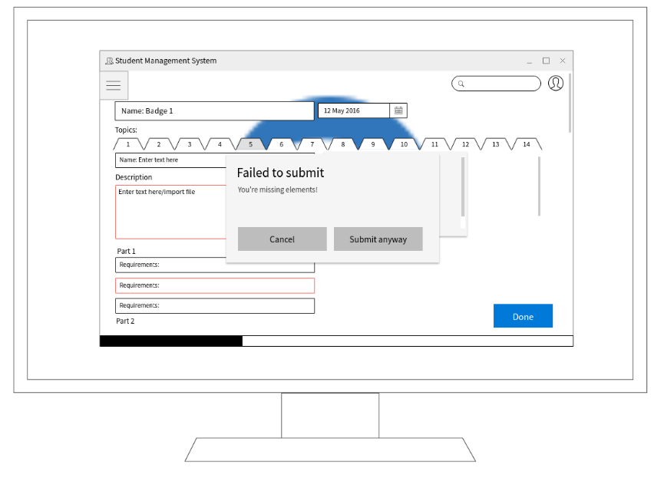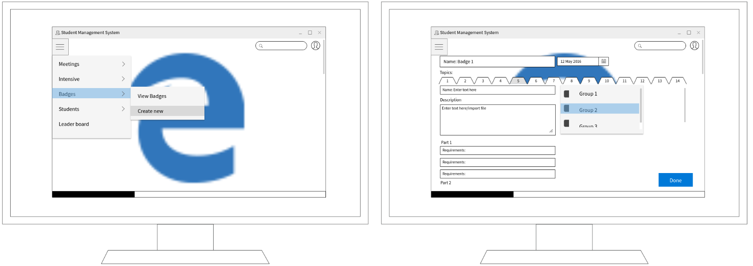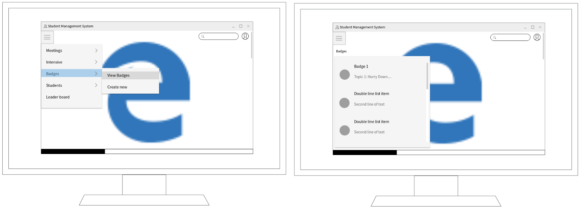Creating a new badge: here you have tabs in which the teacher must work through, filling in all the necessary information required to sufficiently supply students with information and requirements to achieve the badge. There is a warning functionality to ensure this happens.
7. Adding a student: user selects to add a student and are taken to a new page where they input basic student information. Editing a student takes the user to the same page.
8. 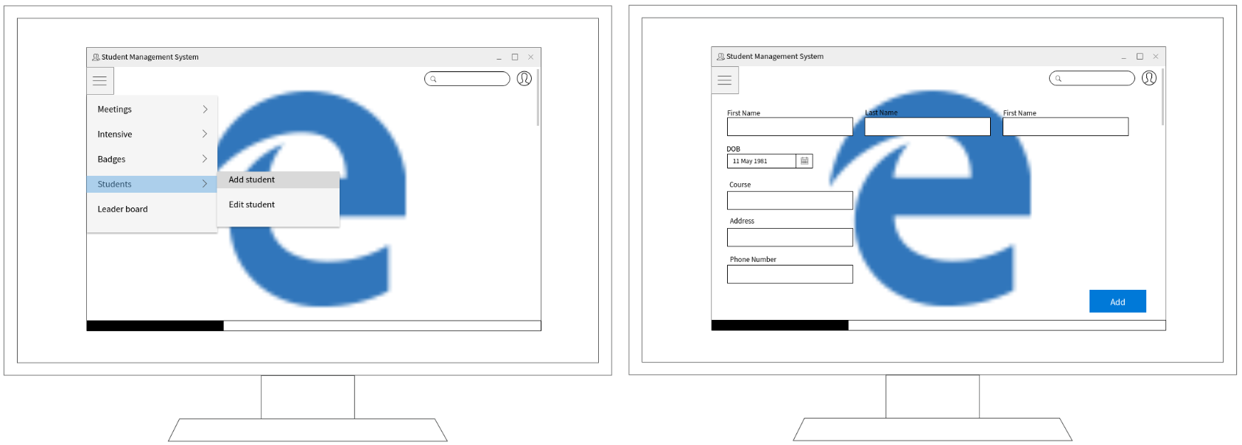Viewing the leader board: 